**INTRODUCTION**

**Title: ML-Based Diagnostic System for Sleep Disorders: A Comprehensive Approach to Prediction and Personalized Therapy**

**Sleep disorders affect a substantial portion of the global population, with an estimated 10-30% grappling with various conditions such as insomnia, sleep apnea, and more. The impact of these disorders extends beyond mere inconvenience, as they can significantly influence overall well-being and lead to the development of other health issues. Recognizing the critical need for early intervention and awareness, our project focuses on leveraging machine learning techniques for predictive modeling and providing personalized suggestions for individuals at risk of sleep disorders.The primary goal of our research is to empower individuals with information about their potential risk levels, even before overt symptoms manifest. Sleep disorders often go undetected until they reach an advanced stage, making early intervention crucial for preventing further health complications. By analyzing preliminary data related to sleep patterns, lifestyle, and other relevant factors, our predictive modeling system aims to assess the likelihood of developing sleep disorders. This proactive approach enables individuals to take timely action, whether by seeking professional medical advice or by implementing home-based remedies.**

**In our project, advanced machine learning techniques such as Support Vector Classifier (SVC), Logistic Regression, Stacking, ExtraTreeClasssifier are employed to create a robust predictive model. These algorithms analyze a diverse set of features, including demographic information, physical health indicators, and subjective assessments, to provide a holistic understanding of the factors influencing sleep patterns. The resulting predictive model not only identifies the probability of an individual developing a specific sleep disorder but also evaluates the associated risk level.Through machine learning algorithms, our system not only predicts the risk level of sleep disorders but also tailors suggestions based on individual traits. This personalized approach ensures that users receive targeted recommendations, ranging from lifestyle modifications to specific home remedies, fostering an environment conducive to healthy sleep.**

**In conclusion, our ML-based diagnostic system for sleep disorders takes a proactive and personalized approach to address the global prevalence of sleep-related issues. By leveraging cutting-edge machine learning techniques, our project not only aims to predict the likelihood and risk levels of sleep disorders but also provides personalized suggestions for intervention.**

**LITERATURE SURVEY**

**2.1 Existing Systems**

**1.Predicting the Risk of Sleep Disorders Using a Machine Learning–Based Simple Questionnaire: Development and Validation Study.**

**Ha S, Choi SJ, Lee S, Wijaya RH, Kim JH, Joo EY, Kim JK**

**Introduction:**

The study introduces the development of SLEEPS, a machine learning–based questionnaire aimed at predicting the risk of obstructive sleep apnea (OSA), comorbid insomnia and sleep apnea (COMISA), and insomnia, leveraging extreme gradient boosting**.**

**Sleep Disorders Included in Paper:**

OSA, COMISA, and insomnia are the focus, highlighted by their common occurrence and potential for serious health implications.

**Methodology:**

Utilized PSG data from two medical centers, employing extreme gradient boosting to develop a questionnaire predicting sleep disorders, and assessing its effectiveness with various statistical measures.

**Algorithms**:

The study compares the performance of XGBoost with logistic regression, random forest, and support vector classifier, selecting XGBoost for its superior performance in classification tasks.

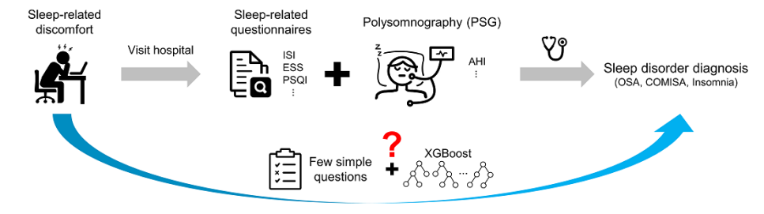**Results:**

The SLEEPS questionnaire demonstrated high accuracy in predicting the risk of OSA, COMISA, and insomnia. It notably outperformed existing models, though faced challenges with data imbalance.

**Conclusion:**

SLEEPS provides an accessible and effective tool for predicting sleep disorder risks, showcasing the potential of machine learning in enhancing diagnostic processes. The study suggests further research to refine the model, particularly considering demographic diversity and data balance.

**2.Brief digital sleep questionnaire powered by machine learning prediction models identifies common sleep disorders.**

**Schwartz, Alan R., Mairav Cohen-Zion, Luu V. Pham, Amit Gal, Mudiaga Sowho, Francis P. Sgambati, Tracy Klopfer et al.**

**Introduction:**

The document introduces a study on developing a brief digital sleep questionnaire (DSQ) to identify common sleep disturbances using machine learning. It emphasizes the prevalence of sleep disorders and the need for efficient, scalable diagnostic tools.

**Sleep Disorders Included in Paper:**

The DSQ targets several sleep disorders, including insufficient sleep, circadian rhythm disorders, and various causes of insomnia, aiming to distinguish between these and other types of insomnia.

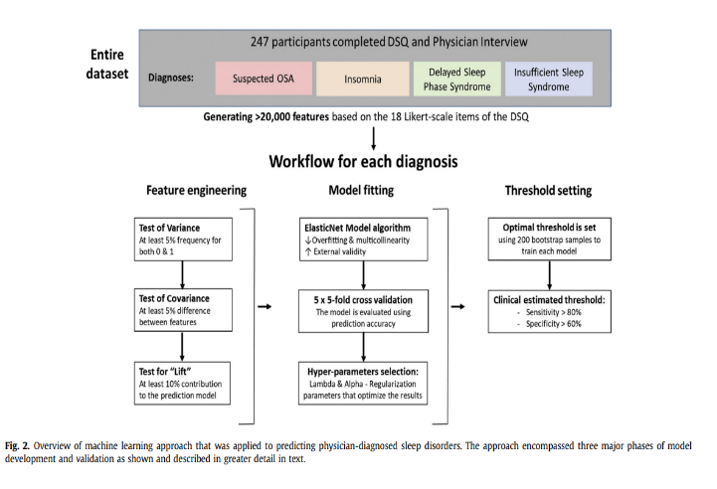**Methodology:**

The study methodology involves recruiting participants through Facebook, administering the DSQ, and following up with interviews at the Johns Hopkins Sleep Center. Data was analyzed using ANOVA, Chi-squared analysis, and machine learning for feature engineering, model fitting, and threshold setting.

**Algorithms:**

ElasticNet, an algorithm incorporating Lasso and Ridge regularization mechanisms, was used for model fitting, aiming to predict sleep disorders with high accuracy while avoiding overfitting and multicollinearity.

**Results:**

The predictive models showed good to excellent diagnostic performance, accurately classifying sleep disturbances with high sensitivity and acceptable specificity across several sleep disorders.

**Conclusion:**

The DSQ presents a novel, efficient tool for screening sleep disturbances in the general population, with machine learning significantly enhancing its predictive accuracy. However, limitations such as small sample size and the potential for overfitting are noted.

**3.Application of various machine learning techniques to predict obstructive sleep apnea syndrome severity.**

**Han, H., Oh, J.**

**Introduction:**

This study focuses on applying various machine learning techniques to predict the severity of Obstructive Sleep Apnea Syndrome (OSAS), a common disorder affecting life quality and cognitive functions. It emphasizes the complexity of diagnosing OSAS, traditionally done through polysomnography, and proposes a novel approach using machine learning for better classification performance.

**Sleep Disorders Included in Paper:**

The paper specifically addresses OSAS, detailing its impact and the importance of accurately assessing its severity.

**Methodology:**

Data including personal information, physical measurements, questionnaire results, and PSG features were analyzed. The American Academy of Sleep Medicine Task Force's severity levels were used to classify the data, which was then processed through various machine learning algorithms for predictive modeling.

**Algorithms:**

The study utilized LightGBM for clustering and applied mutual information and recursive feature elimination for feature selection. Various clustering algorithms like hierarchical agglomerative clustering, K-means, and Gaussian mixture models were employed. For classification, it compared random forest, gradient boosting, and models based on gradient boosting like LightGBM and CatBoost.

**Results:**

Hierarchical agglomerative clustering showed the best performance for clustering, with CatBoost and LightGBM achieving high accuracy in classifying mild to severe OSAS. The study found clustering before classification enhanced model performance for mild and moderate OSAS.

**Conclusion:**

The study demonstrates the effectiveness of machine learning techniques in predicting OSAS severity, offering a promising approach for screening without the need for traditional, more invasive methods. It highlights the potential of machine learning in public health applications, specifically in sleep disorder diagnosis.

4. **A Classification of Sleep Disorders with Optimal Features using Machine Learning Techniques.**

**wongsirichot, t. and hanskunatai, a.**

**Introduction:**

Highlights the significance of diagnosing sleep disorders early, given their link to non-communicable diseases, and the limitations of traditional polysomnography (PSG).

**Sleep Disorders Included:**

Emphasizes on Obstructive Sleep Apnea (OSA) while also mentioning parasomnias, dyssomnias, and circadian rhythm disorders.

**Methodology:**

Details the collection and preprocessing of PSG data, selection of optimal features using information gain values, and evaluation of machine learning algorithms via 10-fold cross-validation.

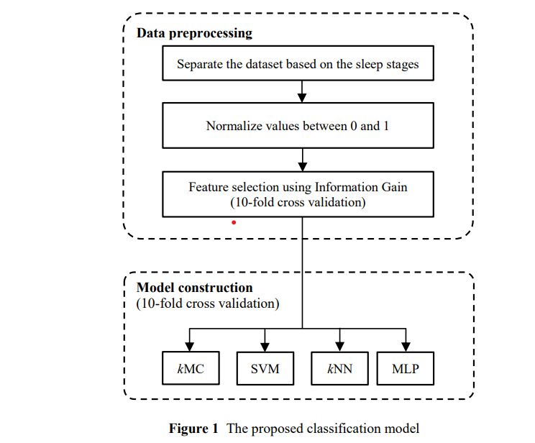**Algorithms:**

Examines four machine learning techniques: k-Means Clustering, k-Nearest Neighbors (kNN), Support Vector Machine, and Multi-Layer Perceptron, to identify the most effective in classifying sleep disorders.

**Results:**

Finds that the kNN algorithm, particularly with a subset of features (PULSE, SAO2, CANR, CHEST), achieves the highest classification accuracy, demonstrating the potential for simplified diagnostics.

**Conclusion:**

Concludes that the study's method, opf-kNN, effectively classifies sleep disorders with high accuracy using minimal equipment, offering a promising approach for settings with limited access to comprehensive diagnostic tools.

**5. Sleep Expert—An Intelligent Medical Decision Support System for Sleep Disorders.**

**Korpinen, L., and H. Frey.**

**Introduction:**

Discusses the development of sleep disorders medicine from neuroscience, highlighting the challenges of mastering various domains within this field. Introduces Sleep Expert, a decision support system designed to aid in diagnosing sleep disorders.

**Sleep Disorders Included in Paper:**

Utilizes the International Classification of Sleep Disorders, focusing on a wide range of sleep disorders by presenting diagnoses with minimal, severity, and duration criteria.

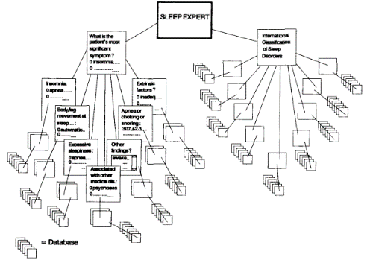

**Methodology:**

Describes the process of developing Sleep Expert, including the classification of symptoms into groups and the use of symptom cards to streamline diagnosis selection to a subset of 10.

**Algorithms:**

Sleep Expert was developed using Knowledgepro, integrating object-oriented programming, hypertext, and expert system technologies, designed for use on PC/AT personal computers through Windows 3.0.

**Results:**

Not explicitly detailed, but the system's structure and user interface suggest a comprehensive tool that supports medical decision-making by providing a flexible, interactive platform for diagnosing sleep disorders.

**Conclusion:**

Sleep Expert is affirmed as a decision support system grounded in the International Classification of Sleep Disorders, developed to enhance medical decision-making in sleep medicine.

**6. Sleep disorder and apnea events detection framework with high performance using two-tier learning model design.**

**Arslan, Recep Sinan**

**Introduction:**

Discusses the significance of early detection for sleep apnea, which includes obstructive, central, and mixed types, affecting millions worldwide.

**Sleep Disorders Included in Paper:**

Focuses on sleep apnea, with data derived from patients showing symptoms of obstructive sleep apnea (OSA).

**Methodology:**

Utilizes a dataset from Yozgat Bozok University, incorporating features like snore, oxygen saturation, and arousal data from 50 patients to balance the study.

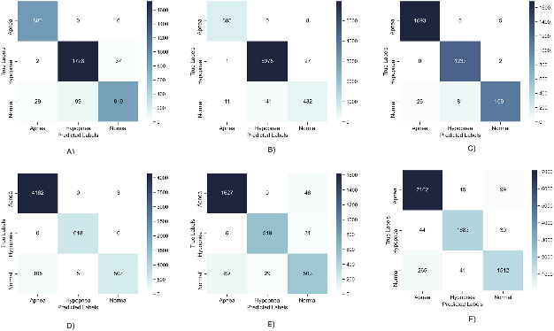**Algorithms:**

The study employs deep learning models (DNN, GRU, RNN, LSTM) in the first layer and a machine learning-based meta-learner in the second layer, tested with various algorithms (e.g., LR, RF, DT).

**Results:**

The two-layer model achieved high performance in detecting sleep disorders, with the meta-learner addressing variability issues in patient data.

**Conclusion:**

The proposed two-tier model effectively detects sleep apnea using 23 sensor data points, offering a promising decision support system for clinical applications, with potential future integration with wearable technologies for real-time detection.

**7.Automated sleep stage detection based on recurrence quantification analysis using machine learning.**

**Karimi Moridani, Mohammad, and Atiye Hajiali**

**Introduction:**

It emphasizes the need for intelligent methods to increase diagnostic accuracy and reduce manual analysis workload in sleep stage classification.

**Sleep Disorders Included:**

Focuses on the classification of various sleep stages rather than specific sleep disorders, aiming to improve the diagnosis of related disorders through accurate sleep stage identification.

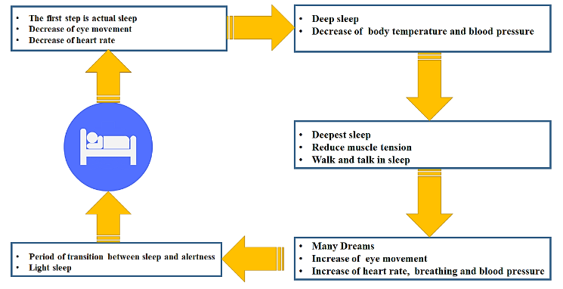

**Methodology:**

Utilizes recurrence plots for nonlinear analysis and feature extraction from EEG signals, followed by normalization and feature selection for optimal classification.

**Algorithms:**

Implements Multi-Layer Perceptron (MLP) neural network for classification, chosen for its effectiveness in handling the complexity of sleep stage data.

**Results:**

Achieved high specificity, sensitivity, and accuracy in distinguishing between Non-Rapid Eye Movement (Non-REM) and Rapid Eye Movement (REM) sleep stages, demonstrating the method's effectiveness over previous studies.

**Conclusion:**

Concludes that the proposed method significantly enhances the automatic classification of sleep stages, offering a promising tool for clinical diagnosis and research on sleep disorders.

**8. Review of Recent Advances in Machine Learning-Based Sleep Apnea Detection Systems**

**Anita Ramachandran and Anupama Karuppiah**

**Introduction:**

Sleep apnea, characterized by disrupted breathing during sleep, poses health risks such as cardiovascular dysfunction, stroke, and diabetes. The gold standard for diagnosis, PSG, is costly and limited in availability. This review explores how machine learning and embedded systems can enhance the accessibility and affordability of sleep apnea detection.

**Sleep Disorders included in paper:**

The paper discusses three types of sleep apnea—Obstructive (OSA), Central (CSA), and Complex Sleep Apnea Syndrome—and their etiological risk factors. It also analyzes the challenges associated with designing effective sleep apnea detection systems based on a literature survey.

**Methodology:**

The review provides insights into the clinical manifestations of sleep apnea and the parameters derived from signals like ECG, EEG, and SPO2 used for diagnosis. It discusses the drawbacks of PSG testing, emphasizing the need for alternative solutions. The review also emphasizes the role of sensors, particularly wearable devices, in making sleep apnea diagnosis more accessible.

**Algorithms:**

The paper categorizes recent research into classic machine learning and deep learning-based solutions for sleep apnea detection. It discusses studies using single markers (SPO2, ECG) for sleep apnea detection and evaluates various machine learning models, such as decision trees, support vector machines, and ensemble classifiers. The review explores the application of deep learning techniques (DNN, CNN, RNN, LSTM) in sleep apnea detection and discusses feature extraction, classification accuracy, and the role of unsupervised learning algorithms.

**Results:**

The authors conclude by highlighting the variability in the accuracy of machine learning algorithms applied to different datasets. Factors influencing algorithm performance include data collection modalities, dataset characteristics, and labeling techniques.

**Conclusion:**

The review emphasizes the importance of addressing these factors to enhance the reliability and generalization capability of sleep apnea detection systems.

**9.** **Obstructive Sleep Apnea: A Prediction Model Using Supervised Machine Learning Method.**

**Introduction:**

In the introduction section, the article highlights the prevalence of Obstructive Sleep Apnea (OSA) as a common sleep disorder affecting a significant portion of the global population. It acknowledges that the gold standard for diagnosing OSA, Polysomnography (PSG), is both time-consuming and expensive. As an alternative, portable sleep monitoring devices using various features such as ECG, EEG, and SpO2 have been proposed. Moreover, the introduction discusses the growing use of machine learning methods in the medical field to predict OSA, underlining the need for more efficient and cost-effective diagnostic tools.

**Sleep Disorders included in paper:**

The primary focus of this paper revolves around Obstructive Sleep Apnea (OSA). While it briefly mentions OSA, the article does not delve into other sleep disorders in significant detail.

**Methodology:**

The paper applies the CRISP-DM methodology to analyze medical records of 250 patients with 49 features related to obstructive sleep apnea (OSA). The Apnea-Hypopnea Index (AHI) is used to label the patients as OSA or healthy. The paper compares different machine learning algorithms and feature selection methods to predict OSA from the features.

**Algorithms:**

The algorithms section is dedicated to detailing the machine learning methods employed in the study. These algorithms include Neural Networks, Naïve Bayes, Logistic Regression, k-nearest neighbor (KNN), SVM, and Random Forest, all of which play a crucial role in the development of predictive models for OSA.

**Results:**

In the results section, the article presents key findings based on the research. The dataset ultimately consists of 231 records, with a majority (65.8%) diagnosed with OSA. The distribution of subjects includes a predominantly male population (61.9%).

**Conclusion:**

The conclusion section summarizes the key takeaways from the study. It underscores that machine learning methods, when applied to self-reported symptoms and readily available features, display significant efficiency in predicting OSA. This approach is suggested as a rapid and cost-effective auxiliary tool for physicians and medical staff to screen high-risk OSA patients, potentially improving early diagnosis and intervention.

## **10.Sleep Apnea Detection Using Deep Learning Methodologies**

**Introduction:**

The introduction section of the paper provides a comprehensive overview of the research focus. It highlights the importance of identifying and diagnosing sleep disorders, with a particular emphasis on sleep apnea. The introduction underscores the utilization of deep learning techniques for analyzing ECG and SpO2 data as a means of sleep apnea detection. It introduces the primary objective of the study, which is to evaluate the effectiveness of heart rate and SpO2 data collected via a smartwatch in predicting sleep apnea. In doing so, this section sets the context for the subsequent sections, emphasizing the significance of the research problem.

**Sleep Disorders included in paper:**

While there may not be a dedicated heading for this section in the document, various sleep disorders are discussed, with a primary focus on sleep apnea. The paper briefly mentions other sleep disorders mentioned in the cited research papers but primarily centers around sleep apnea. It provides context for the specific sleep disorder under investigation, establishing its relevance within the study.

**Methodology:**

The methodology section outlines the research approach taken in conducting the study. It describes the dataset utilized for the research, highlighting the nature and source of the data. The document delves into the technical aspects of data processing, including data partitioning and the transformation of data into spectrograms. Moreover, it mentions the application of dimension reduction techniques like Principal Component Analysis (PCA) and the use of Eigenvalues to create matrices representing primary components for each class. This section also introduces the deep learning models employed for sleep apnea classification.

**Algorithms:**

The algorithms section provides detailed insights into the specific deep learning models employed for sleep apnea detection. It discusses two primary models: the Baseline Convolutional Neural Network (CNN) and the DenseNet121 + CNN. The architecture of these models is described, including the number of layers, kernel sizes, and activation functions. This section serves to elucidate the technical aspects of the models used for the research.

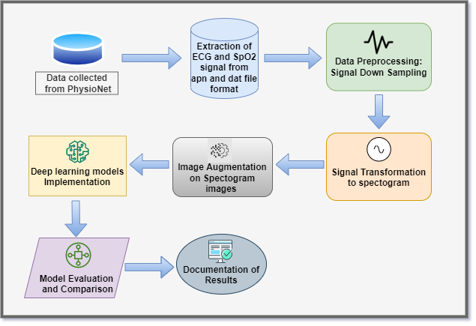

**Results:**

The results section reports the outcomes of the research and the performance of the deep learning models. It includes essential evaluation metrics such as accuracy, F1-score, precision, and recall, among others. The document presents graphical representations of accuracy and loss to visualize the performance of the models. The results section highlights the accuracy and efficacy of the models in sleep apnea detection, potentially making comparisons between different models used in the study.

**Conclusion:**

The conclusion section succinctly summarizes the major findings and key takeaways from the research. It reiterates the performance of the deep learning models and any valuable insights gleaned from the study. Additionally, the section acknowledges the limitations of the research, such as dataset size and data sources. It suggests possible directions for future research, such as the use of larger

datasets or the inclusion of additional data sources. Ultimately, the conclusion reinforces the significance of employing deep learning models for sleep apnea detection, with the ultimate goal of streamlining the diagnostic procedure.

**11 .A Review of Automated Sleep Disorder Detection**

**Shuting Xua, Oliver Faustb, Seoni Silviac, Subrata Chakrabortye, Prabal Datta Baruaa, Filippo**

**Molinaric, U. Rajendra Acharya**

**Introduction:**

The introduction section of the paper highlights the critical importance of sleep stage classification for assessing sleep quality, aligning with the American Academy of Sleep Medicine (AASM) standards. It identifies various sleep disorders, including Periodic Limb Movement Disorder, Rapid Eye Movement Behavioral Disorder, bruxism, obstructive sleep apnea, and insomnia, as substantial health concerns affecting a broad population. The prevalence and physiological implications of these disorders are discussed, emphasizing the individuality and variability of sleep disturbances, necessitating disease-specific treatment and objective detection for accurate diagnosis. The paper introduces the central theme of leveraging digital technology and Artificial Intelligence (AI) for automating sleep disorder diagnosis support.

**Sleep Disorders included in this paper:**

This section outlines the various sleep disorders covered in the paper, including Obstructive Sleep Apnea (OSA), Hypopnea, Insomnia, REM sleep behavior disorder, Narcolepsy, Nocturnal Frontal lobe epilepsy, and Bruxism. It provides a concise list of the specific sleep disorders addressed within the document.

**Methodology:**

The methodology section of the paper introduces the research approach used in the study. It explains how automated sleep disorder detection, incorporating Artificial Intelligence (AI) models, is employed to overcome the limitations of manual analysis and enhance remote monitoring in a home environment. It categorizes the information channels into three components: feature extraction, machine learning (ML) algorithms, and deep learning (DL) methods. The paper discusses the primary physiological signals used in sleep apnea diagnosis, including EEG, ECG, EMG, and EOG, within the context of AI models. It highlights the adoption of DL models like Convolutional Neural Network (CNN) and Recurrent Neural Network (RNN) to improve classification accuracy. Benchmark datasets for sleep disorder detection and related reviews on sleep disorders are presented, establishing the groundwork for the study.

**Algorithms:**

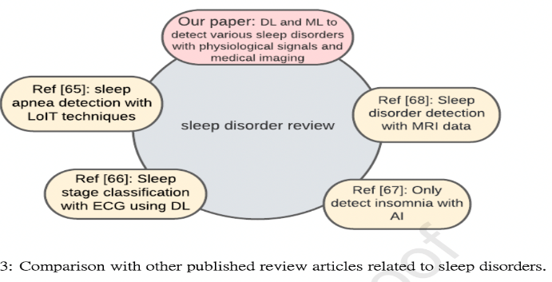This section provides insights into the algorithms and methods used for automated sleep disorder detection. It categorizes and discusses the approaches taken for different sleep disorders, including Sleep Apnea, Insomnia, REM Sleep Behavior Disorder (RBD), Hypopnea, Narcolepsy, Periodic Limb Movement Disorder (PLMD), and Bruxism. The choice of machine learning (ML) or deep learning (DL) methods is highlighted, along with their respective performances in each disorder category.

**Results:**

The results section delves into the application of Artificial Intelligence (AI) techniques for the detection of specific sleep disorders. It categorizes and discusses the outcomes for various sleep disorders, including Sleep Apnea, Insomnia, REM Sleep Behavior Disorder (RBD), Hypopnea, Narcolepsy, Periodic Limb Movement Disorder (PLMD), and Bruxism. The section provides insights into the signals utilized, such as EEG, ECG, and PSG, and the performance metrics achieved by different AI models. It showcases the evolving landscape of AI-based automated sleep disorder detection.

**Conclusion:**

The conclusion section summarizes the key findings and takeaways from the paper's comprehensive review of automated sleep disorder detection. It underscores the shift from Machine Learning (ML) to Deep Learning (DL) methods, with a focus on individual sleep disorders such as sleep apnea and insomnia. The importance of AI-based detection in home environments and the need for research on publicly available databases are highlighted. The paper advocates for signal acquisition in home settings to improve disease prediction and interventions, emphasizing the significance of ongoing efforts in the field of automated sleep disorder detection for global sleep health enhancement.

**12.Sleep APNEA Analysis by Machine Learning Algorithms Using ECG Signals**

**V.Ankitha,P.Manimegalai, Dr.P.Subha Hency Jose, Raji.P**

**Introduction:**

The introduction section provides an overview of the paper, focusing on the application of various Machine Learning (ML) and Deep Learning (DL) methods for the detection and diagnosis of Sleep Apnea. It highlights the number of research articles analyzed and mentions the superior performance accuracy of Convolutional Neural Network (CNN) and Long Short-Term Memory (LSTM) classifiers in Sleep Apnea detection. The importance of accurate sleep stage detection and the limitations of traditional assessment methods are discussed. The section sets the context for the study.

**Sleep Disorders included in this paper:**

It emphasizes the focus on Sleep Apnea (SA) detection using ML and DL methods.

**Methodology:**

The methodology section describes the approach used in the study, which involves the simultaneous detection of sleep stages and sleep disorders using multimodal sensory data (EEG, ECG, and EMG). It introduces the Multimodal and Multilabel Decision-Making System (MML-DMS), consisting of interconnected classifier modules, CNNs, and perceptron neural networks (NNs).

**Algorithms:**

The algorithms section discusses the components of the proposed MML-DMS, including CNNs and NNs, used for sleep stage and sleep disorder classification. It also highlights the importance of information fusion from multiple modalities and labels to improve classification results.

**Results:**

The results section presents the outcomes of the experiments conducted using the MML-DMS. It covers three experiments: single-modality classification, multimodal classification, and multimodal and multilabel classification.

**Conclusion:**

The conclusion section summarizes the key findings of the study, emphasizing the effectiveness of the MML-DMS in simultaneously recognizing sleep stages and sleep disorders. It mentions the high accuracy rates achieved for sleep stage recognition (94.34%) and sleep disorder recognition (99.09%) on the PhysioNet CAP Sleep database. The section also acknowledges the need for further research to refine sleep stage classification and explores different classifier structures.

**13. Detection and Classification of Obstructive Sleep Apnea Disorders: A Comparative Analysis of Various Deep Machine Learning Classifiers**

**Madhavi Kemidi, Venkat Krishna Chantigari.**

**Introduction:**

The introduction section provides an overview of Sleep Apnea (SA), a respiratory disorder characterized by upper respiratory tract blockages, leading to disruptive snoring and repeated breathing interruptions during sleep. It highlights the symptoms and adverse effects of SA on vital functions. The section outlines the structure of the paper, including the topics covered in subsequent sections, setting the context for the research.

**Sleep Disorders included in this paper:**

This section mentions the primary focus of the paper, which is Sleep Apnea (SA). While other sleep disorders are not explicitly listed here, the paper's primary emphasis is on SA, its diagnosis, and detection.

**Methodology:**

The methodology section describes the approach taken in the project. It mentions the utilization of Electrocardiogram (ECG) signals for SA detection, particularly from the Apnea-ECG database on PhysioNet.

**Algorithms:**

This section introduces the machine learning and deep learning algorithms employed in the study for SA detection. It mentions various classifiers, including SVM, DNN, RNN, CNN, LSTM, and others, used in different stages of the detection process

Results:

The results section provides insights into the outcomes of the research related to the application of machine learning and deep learning methods for SA detection. It mentions the use of Convolutional Neural Network (CNN) and Long Short-Term Memory (LSTM) classifiers, highlighting their superior performance accuracy in SA detection.

**Conclusion:**

The It highlights the effectiveness of various machine learning and deep learning methods in SA detection, particularly the success of CNN and LSTM classifiers. The section acknowledges the evolving nature of research in this field, emphasizing the ongoing investigation into deep neural networks and parameter optimization for improved SA detection

**14.Simultaneous Sleep Stage and Sleep Disorder Detection from Multimodal Sensors Using Deep Learning**

**Yi-Hsuan Cheng, Margaret Lech, Richardt Howard Wilkinson.**

**Introduction:**

The paper introduces the concept of an automatic sleep scoring algorithm and proposes a Multimodal and Multilabel Decision-Making System (MML-DMS) to tackle complex sleep stage and sleep disorder classification tasks.

**Sleep Disorders included in this paper:**

It focuses on the application of ML and DL methods for Sleep Apnea detection and diagnosis. The primary emphasis is on Sleep Apnea.

**Methodology:**

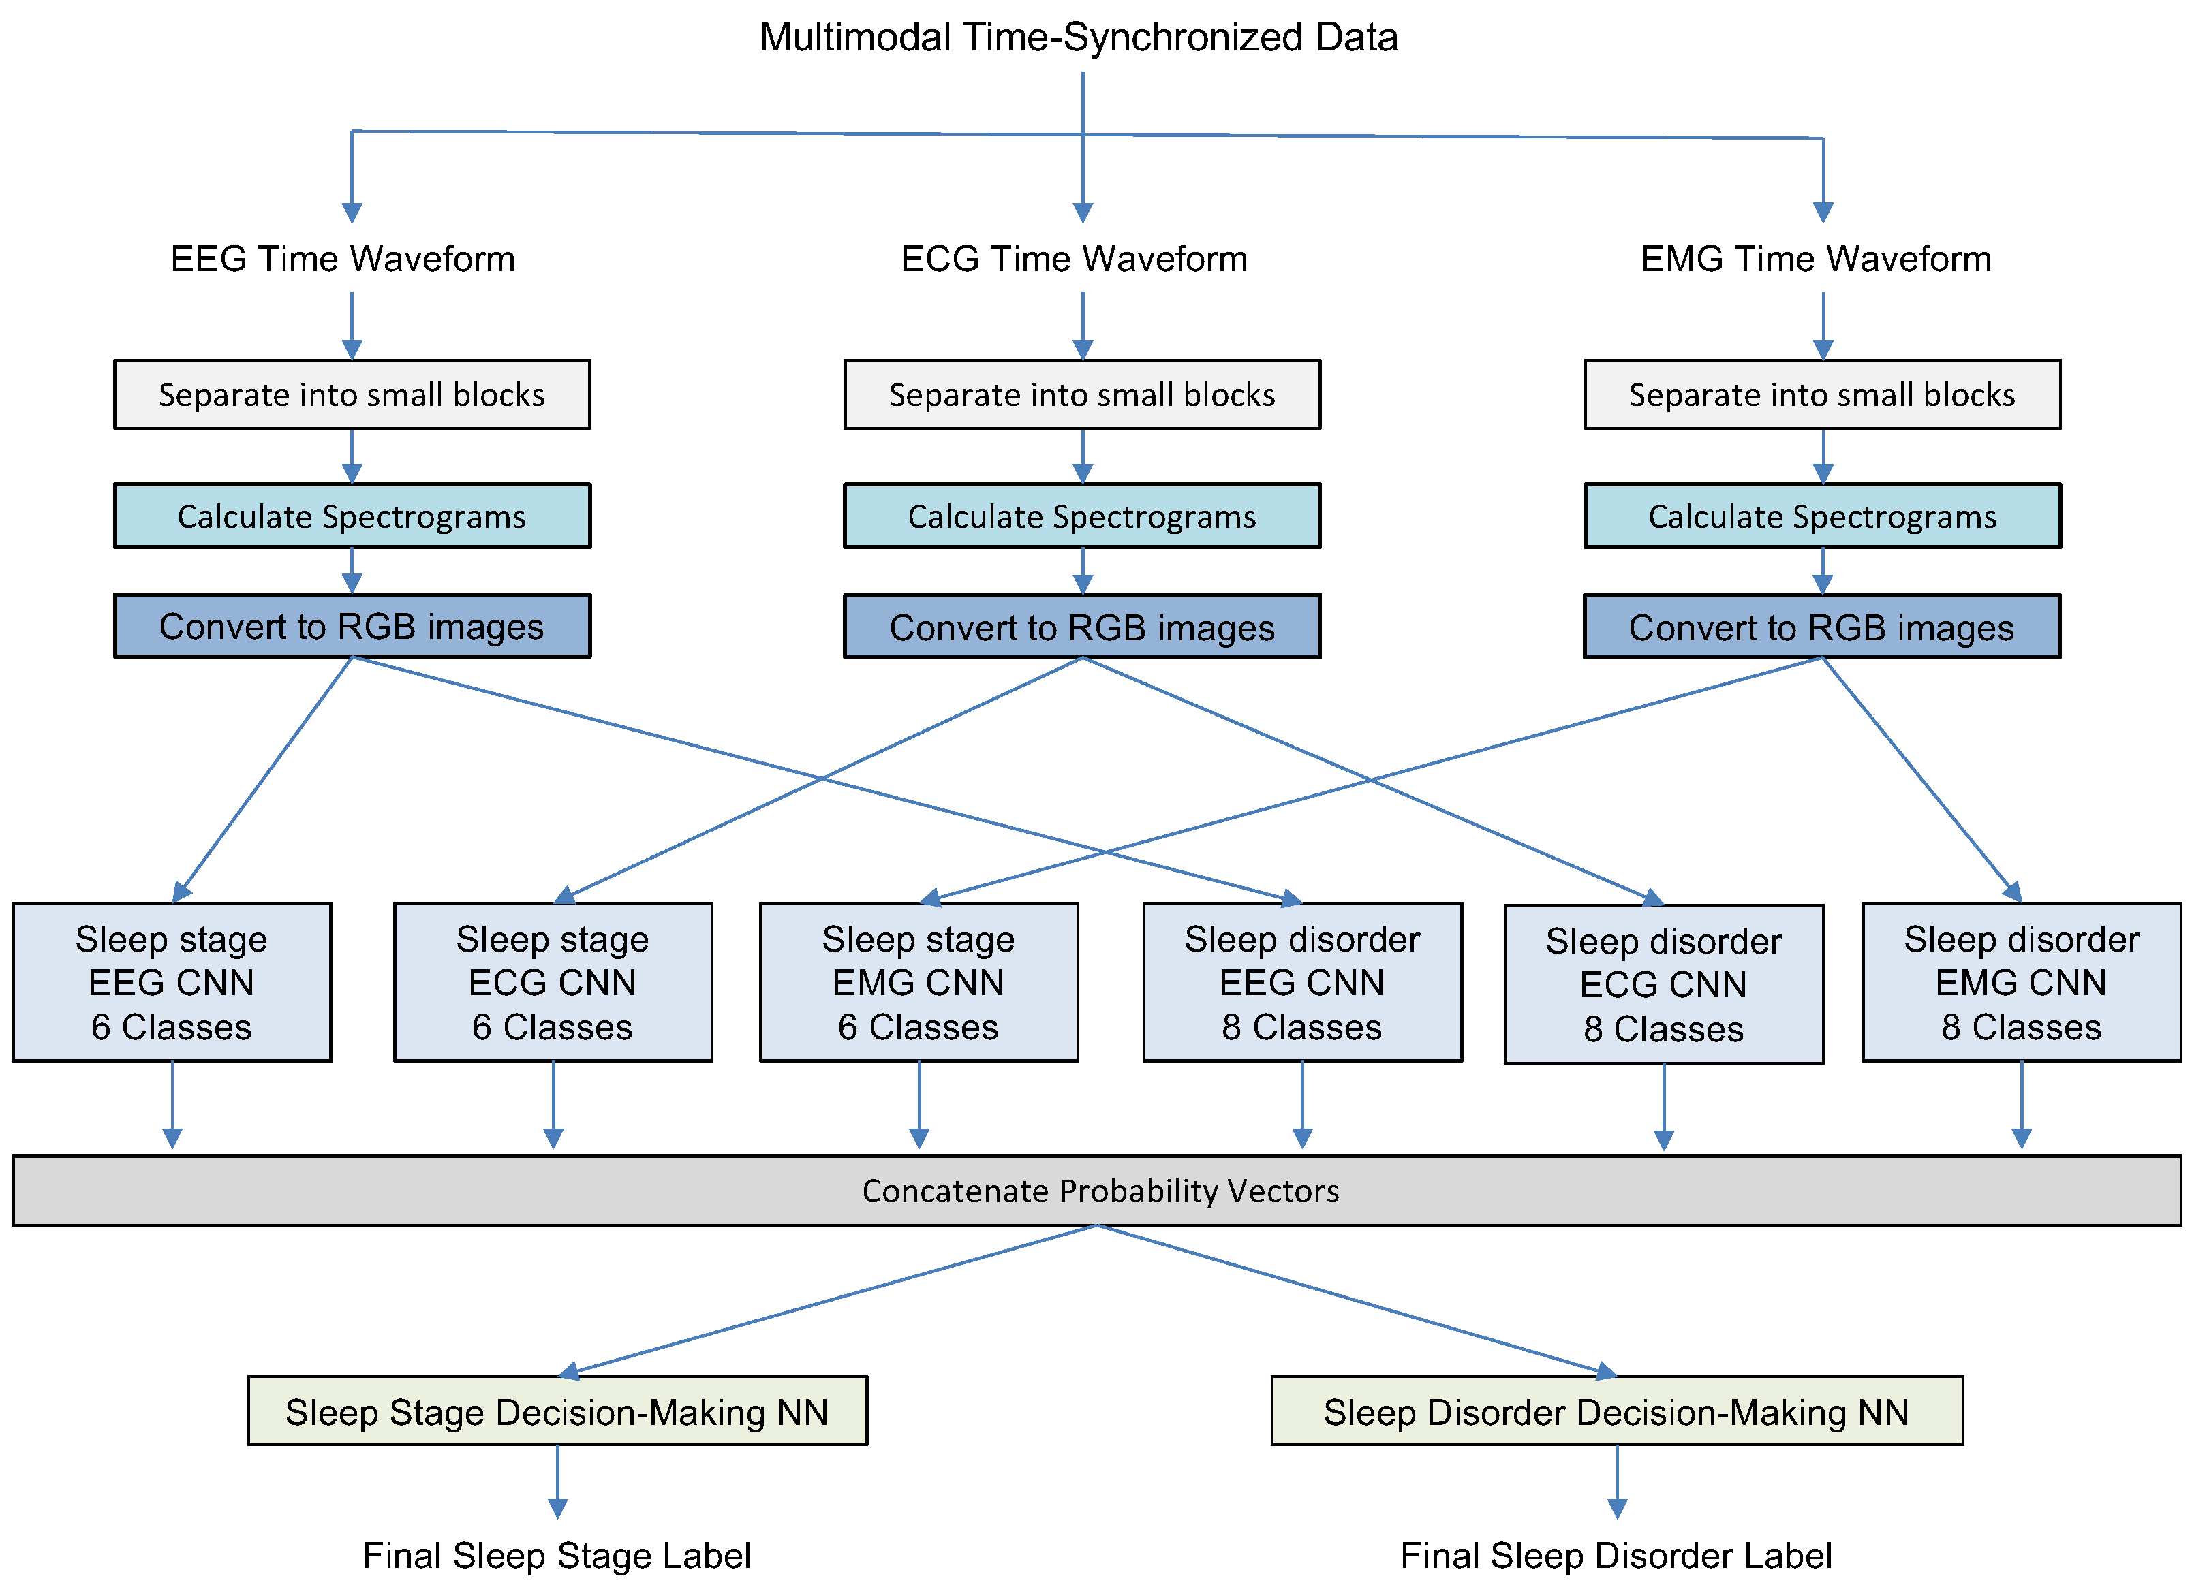The methodology section describes the approach taken in the paper. It explains the use of multimodal sensory data, including EEG, ECG, and EMG, for the

**Algorithms:**

This section covers the details of the algorithms and approaches used in the paper's methodology. It mentions the use of deep convolutional neural networks (CNNs) and perceptron neural networks (NNs) for each data modality, including EEG, ECG, and EMG. The information flow and fusion of multimodal and multilabel data are discussed.

**Results:**

The results section provides insights into the outcomes of the experiments conducted using the proposed MML-DMS. It discusses the performance of the system in terms of sleep stage recognition and sleep disorder detection. The paper mentions high classification accuracy rates of 94.34% for sleep stage recognition and 99.09% for sleep disorder recognition, showcasing the success of the MML-DMS.

**Conclusion:**

The conclusion section summarizes the key findings of the paper. It highlights the success of the MML-DMS in simultaneously recognizing sleep stages and sleep disorders, with the accuracy rates mentioned earlier.

15.**A Machine-Learning Approach for Accurate Sleep Apnea Detection Using Electronic Health Data**

Ashir Javeed, Johan Sanmartin Berglund, Ana Luiza Dallora, Muhammad Asim Saleem,Peter Anderberg

**Introduction:**

The introduction section of the paper provides an insightful overview of sleep apnea and its intricate association with various health conditions, primarily focusing on cardiovascular issues. It underlines the prevalence of sleep apnea, particularly obstructive sleep apnea (OSA), and its profound links to coronary artery disease, heart failure, stroke, and atrial fibrillation. The narrative underscores the paramount importance of identifying and treating sleep apnea due to its far-reaching impact on neurobehavioral disorders, quality of life, and healthcare utilization. Moreover, it accentuates the extensive research exploring the connection between OSA and heart diseases, effectively emphasizing the necessity for robust screening, accurate diagnosis, and timely intervention. Furthermore, it alludes to the American Academy of Pediatrics' recommendation for screening children exhibiting symptoms or having risk factors for sleep apnea. In addition, the paper touches upon the utilization of machine learning algorithms to predict sleep apnea, drawing insights from factors like age, gender, BMI, and medical conditions. The introduction effectively sets the stage for the subsequent sections, encapsulating the multifaceted nature of sleep apnea and its repercussions on health and well-being.

**Sleep Disorders included in this paper:**

The paper does not explicitly enumerate the sleep disorders included in the research. Nevertheless, it unmistakably underscores its primary focus on the detection of Sleep Apnea (SA) employing Machine Learning (ML) and Deep Learning (DL) methodologies. While it doesn't delve into an exhaustive list of sleep disorders, the paper underscores the significance of SA detection within the broader context of sleep disorders and their potential implications for health and quality of life.

**Methodology:**

The methodology section serves as a foundational introduction to the realm of Deep Learning (DL), a subset of Artificial Intelligence (AI) that emulates the intricate data processing and pattern recognition capabilities of the human brain. It delineates DL as a sophisticated branch of machine learning (ML) that harnesses the potential of layered Artificial Neural Networks (ANNs). The discussion traverses through different forms of ANNs, with a notable emphasis on **Recurrent Neural Networks (RNNs)** and Long-Short-Term Memory (LSTM) networks. RNNs are spotlighted for their prowess in processing sequential data, thanks to their recurrent (circular) connection mode. The narrative elaborates on RNNs' capacity to maintain hidden layers, employ past outputs as inputs, and retain information beyond training, though it acknowledges challenges such as vanishing gradients that limit their ability to capture long-term dependencies

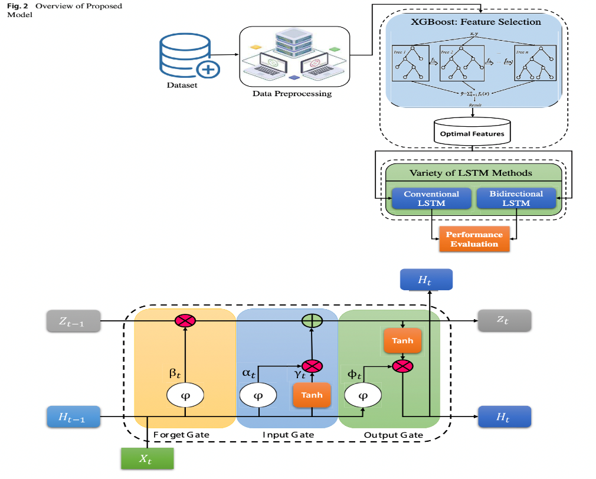

**Algorithms:**

The algorithms section provides a detailed exposition of the novel ML model introduced in the paper, denominated as XGBoost_BiLSTM, formulated for the prediction of sleep apnea via Electronic Health Records (EHR). This hybrid model amalgamates two key comp onents: firstly, the application of XGBoost for feature selection from the dataset, and secondly, the utilization of conventional Long Short-Term Memory (LSTM) and Bidirectional LSTM (BiLSTM) models for predicting sleep apnea based on the selected features. The section illuminates XGBoost as an algorithmic technique that excels in ranking variables within datasets, laying the groundwork for efficient feature selection. It proceeds to elucidate the architectural intricacies of XGBoost, alongside conventional LSTM and BiLSTM structures. Conventional LSTM is depicted as an RNN variant, mirroring typical RNN control flow while incorporating additional cellular activities, thereby enabling it to retain or discard information via input, output, and forget gates. Moreover, the Bidirectional LSTM (BiLSTM) concept is introduced as a mechanism to enhance classification performance by simultaneously training two LSTMs on both the original input data and its reversed counterpart, addressing the vanishing gradient predicament in conventional RNNs.

**Results :**

In the results section, the study evaluates the performance of the introduced XGBoost_BiLSTM model concerning the prediction of sleep apnea. This evaluation encompasses a series of three sets of experiments that shed light on the model's efficacy. Firstly, the section delineates the comparison between Conventional LSTM and BiLSTM models using all 75 features of the dataset. In this comparison, BiLSTM emerges as the frontrunner, achieving a test accuracy rate of 95.12%, outperforming Conventional LSTM's 94.56%. An array of performance metrics, including sensitivity, specificity, F1 score, and Matthews Correlation Coefficient (MCC), corroborate BiLSTM's superiority. Secondly, the experiments delve into the hybridization of the XGBoost model with the BiLSTM model. XGBoost is employed for feature ranking, followed by the selection of top-ranked features based on a threshold, which are then integrated into the BiLSTM model. Remarkably, the proposed XGBoost_BiLSTM model attains a strikingly high test accuracy rate of 97.00%, leveraging only the top six features from the dataset. Furthermore, this section scrutinizes the performance using diverse evaluation metrics. Lastly, the study extends its evaluation to include various modern machine learning models, including Random Forest (RF), in a comprehensive assessment utilizing all 75 features of the dataset. RF emerges as the top performer in this context, achieving a test accuracy rate of 83.40%. Additionally, the utilization of ROC curves adds another layer of evaluation, with RF displaying exceptional performance. These results underscore the efficacy and potency of the proposed XGBoost_BiLSTM model, which seamlessly combines feature selection with XGBoost and sleep apnea classification with BiLSTM. It is evident that the hybrid model achieves commendable accuracy rates, particularly when capitalizing on a refined set of top features, underscoring its immense potential for the early detection and diagnosis of sleep apnea in older adults.

**Conclusion:**

The conclusion section encapsulates the pivotal findings of the study, reinforcing the superior performance of the introduced XGBoost_BiLSTM model in predicting sleep apnea. The section explicitly references the high accuracy rate of 97.00% achieved when utilizing a succinct set of top features. This remarkable performance underscores the potential of the model for the early detection and diagnosis of sleep apnea, particularly within the context of older adults. The section aptly acknowledges the significance of the study's contributions to the field of sleep apnea prediction, emphasizing the model's effectiveness in leveraging electronic health records (EHR). The conclusion provides a resonating closure, solidifying the paper's findings and implications for future research endeavors within this domain.